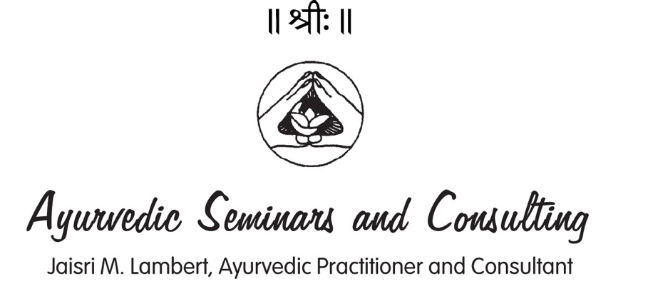

WAIVER/RELEASE FORM FOR SERVICES OF JAISRI M. LAMBERT, AYURVEDA DOCTOR (NAMA)

604-290-8201 www.ayurveda-seminars.com

Name: ___________________________________________________________________________________

Address: _________________________________________________________________________________
______________________________________________________________ Postal Code: ________________

Phone: ___________________________________ Birthdate: _______________________________________

E-Mail: ___________________________________________________________________________________

I, The undersigned, am the person named above or the legal guardian(s) of the above named minor. I know that by signing this form, I acknowledge having read, understood and agreed to all of the following. I understand that Jaisri M. Lambert is an Ayurveda Doctor (N.A.M.A.) and not a medical doctor. I understand she offers Ayurveda services such as consultation, bodywork and education as an alternative to healing arts services currently licensed by the government of British Columbia and Canada.

Ayurveda is a system of healing that has its roots in ancient India. As the world’s oldest holistic health system, Ayurveda is a medical science whose purpose is to help regain health and maintain the quality, vigor and longevity of life. I understand it offers a profound understanding of each person’s unique self-healing process of body, mind and consciousness. This understanding is considered as the foundation of health and happiness according to Ayurveda.

Jaisri M. Lambert has completed a twelve-year apprenticeship with Vaidya Vasant D. Lad, B.A.M. & S., MA.Sc. and others. Under his and others’ guidance, she has gained competence in pulse assessment, herbal formulations and panchakarma. Her background is in education, Polarity Therapy, counseling and meditation. She has been practicing and teaching natural healing methods since 1983.

I agree to hold harmless Jaisri M. Lambert, Ayurveda Seminars & Consulting, any affiliated organizations and persons associated or affiliated with Jaisri M. Lambert or heirs thereof, for any information or suggestions given to me during my association with her, by any means such as interview, telephone, internet, email or any other. I acknowledge that I am completely, wholly and solely responsible for my physical and psychological health and well-being and self-healing process. I understand that the information Jaisri M. Lambert gives me is for educational purposes only. Ms. Lambert makes no warranty or guarantee of these services. Please consult your physician before making any lifestyle changes.

By signing this, I agree and I acknowledge that medical and other healthcare and treatment I receive from Jaisri M. Lambert, will be provided in the province or territory of British Columbia, Canada, and that the Courts of British Columbia, Canada, shall have exclusive jurisdiction to hear any complaint, demand, claim, proceeding, or cause of action, whatsoever arising from or in connection with the healthcare healing art, or from any other relationship between myself and Jaisri M. Lambert.

To utilize Jaisri M. Lambert’s services, I acknowledge the information provided in this form and affix my signature. I acknowledge having read, understood and agreed to all of the above. This document will remain in her records for at least three years. This waiver and release of liability must be acknowledged and signed prior to any professional or informal dialog.

Signature: ________________________________________________________________________________

Date: ___________________________________________________________________________________

Relationship to the above named minor or elder: _____________________________________________________

